

## Notes:

## The First day of school is **TUESDAY** September 5th!

## There will be a Parent Orientation Thursday September 7th at 6 pm.

## We are inviting all parents to join the remind app as an immediate and alternative form of communication with teachers about reminders and happenings in the classroom! For anyone having trouble, we will go over how to log in through your phone at parent orientation!

## Please remember to bring in all completed paper work by the first day of class! All students MUST have up-to-date immunization record or signed and notarized immunization exemption paper work before coming to class on the first day! Without all the necessary documents the student will not be able to attend class!

Snack:

9/5 Tanner

9/6 Caleb

9/7 Odessa

Don’t Forget to Like us on Facebook!!



Color:

**BLUE**

3 to 5 Weekly

Theme:

ALL ABOUT ME!

Week1

9/5-9/7

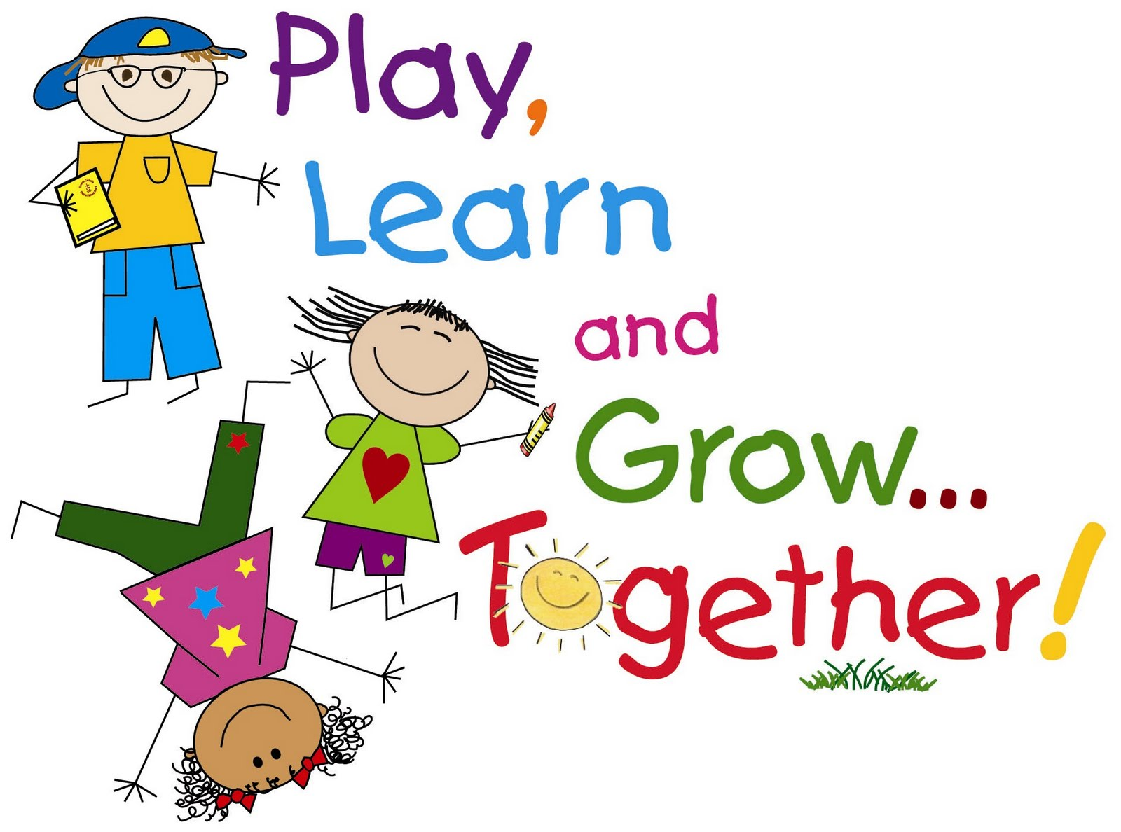

|  |  |  |  |
| --- | --- | --- | --- |
| Monday  NO SCHOOL | Tuesday  Classroom Choices | Wednesday  The Kissing Hand | Thursday  My Many Colored Days |

This week we will be learning all about ourselves, our classroom, and the things we can do to be good friends! We would like to invite parents to bring up topics with their children to learn more about their days in Pre-K!

1. You read a book in class called “My many colored days”- what color day did you have at school?
2. What are some of the green choices you can make at school? What are some of the red choices?

Table Talk: